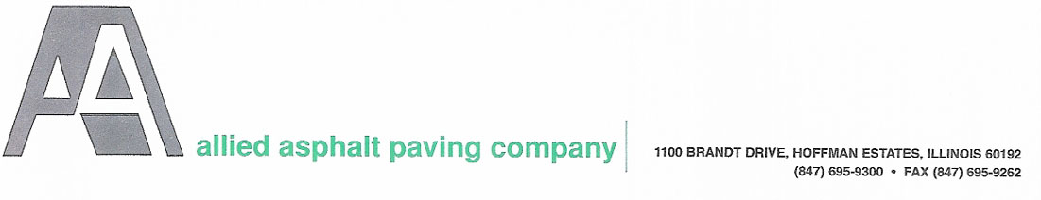
DAILY ORDER FORM

Today’s Date:______________________

PLANT LOCATION
DATE NEEDED
DAY SHIFT OR NIGHT SHIFT ?
TYPE OF ASPHALT
LOAD TIME
# OF TRUCKS
TONS PER HOUR NEEDED
TOTAL TONS NEEDED FOR DAY
TOTAL TONS NEEDED FOR ORDER (IF MULTIPLE DAYS)
WILL CALL ?
CUSTOMER NAME
CONTACT NAME
PHONE NUMBER
JOB NAME
JOB LOCATION / ADDRESS
TAX EXEMPT ?
TESTING REQUIRED
STATE CONTRACT #
STATE FAXED INFO

**FAX TO THE PLANT THAT YOU WILL BE PURCHASING THE MIX FROM**
**FAX PRIOR TO 1:00PM**

PLANT LOCATION | PLANT FAX NUMBER
BARTLETT | (630) 497-0818
FRANKLIN PARK | (847) 233-9772
HUNTLEY | (847) 669-2213
WEST CHICAGO | (630) 293-5452

